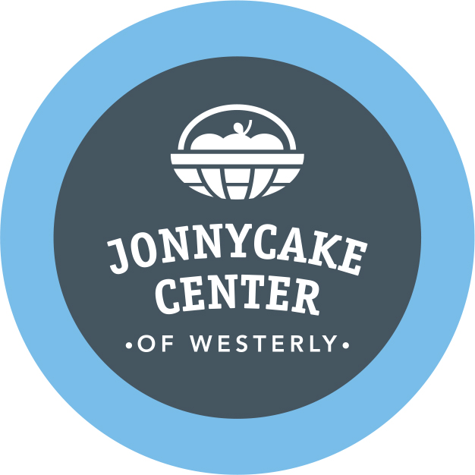

The Jonnycake Center of Westerly’s 8th Annual
Ballroom Bowling Bash
Saturday, January 25, 2020: 7 – 10 pm
Alley Katz Bowling Center 116 Granite Street Westerly, RI

SPONSORSHIP REGISTRATION FORM
Thank you for your willingness to support the Jonnycake Center of Westerly as a Bowl-A-Thon Sponsor. Your tax-deductible donation helps make it possible for Jonnycake to continue to help
local neighbors in need from Westerly, Charlestown, Hopkinton, and Richmond, RI.
On behalf of those who will benefit from your support, thank you!
Sponsoring Organization _________________________________________________________
Address _______________________________________________________________________
Telephone __________________________ Website ___________________________________
Contact Person’s Name ______________________Contact’s Email _______________________
Please select from the following levels of Sponsorship:
___ Perfect Game $300: Your business name and logo displayed over a bowling lane and ball return, recognition on the big screen throughout the evening and all-you-can-roll bowling, shoes rental, and munchies for a Team of six bowlers. Ballroom Bowling attire strongly encouraged – prizes awarded! Please send your camera-ready logo by email to Bambi Poppick at bpoppick@jonnycake.org
___ High Roller $150: Your business name and logo displayed over a lane for the entire evening. Please send your camera-ready logo by email to Bambi Poppick at bpoppick@jonnycake.org

___ Strike $100: Your business name and logo displayed at our raffle table for the entire evening. Please send your camera-ready logo by email to Bambi Poppick at bpoppick@jonnycake.org

___ A Gift Item or Gift Card/Certificate to be featured in the popular Raffle/Silent Auction Showcase
Description:_____________________________________________________________________
___ A Donation of Food / Munchies / Refreshment Description: __________________________

Please return this form with payment to
Bowl-A-Thon Sponsorship – Jonnycake Center of Westerly
23 Industrial Drive, Westerly, RI 02891
The Jonnycake Center of Westerly is a 501©3 non-profit organization. Your donation is 100% tax deductible. For more information please contact Bambi Poppick at (401) 377-8069 ext. 105

