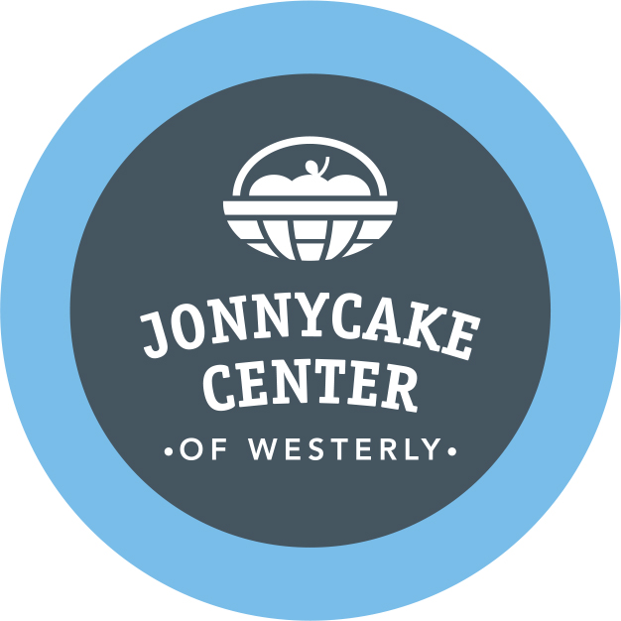

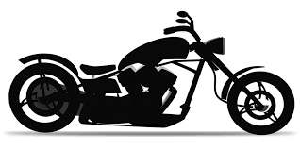

The Iron Order Motorcycle Club Independence Crew, out of Westerly, Rhode Island, will be holding their Annual Motorcycle Run to support The Jonnycake Center of Westerly. The run will take place on Saturday, October 9, 2021 at noon at the Bradford Social Club.

SPONSORSHIP REGISTRATION FORM
Thank you for your willingness to support this event!
Your support helps make it possible for Jonnycake to continue to help
local neighbors in need from Westerly, Charlestown, Hopkinton, and Richmond, RI.
On behalf of those who will benefit from your support, thank you!
Sponsoring Organization _________________________________________________________
Address _______________________________________________________________________
Telephone __________________________ Website ___________________________________
Contact Person’s Name ______________________Contact’s Email _______________________
Please select from the following levels of Sponsorship:
Chopper - $250 • Emcee Recognition at the Event
• Promotion through website and Facebook

Sidecar – $100
• Promotion through website and Facebook

We would be happy to include any promotional items you provide in the biker goody bags whether you are a sponsor or not.

Please return this form with payment to
Jonnycake Center of Westerly
23 Industrial Drive, Westerly, RI 02891
The Jonnycake Center of Westerly is a 501©3 non-profit organization. Your donation is 100% tax deductible. For more information please contact Bambi Poppick at (401) 377-8069 ext. 105

Please send your camera-ready logo by email to Bambi Poppick at bpoppick@jonnycake.org

